NEPAL COLLEGE OF INFORMATION TECHNOLOGY

Level: Bachelor | Semester – Fall | Year : 2015
Programme: BEIT |  | Full Marks : 100
Course: Electronic Circuit and Instrumentation |  | Time : 3hrs.

Candidates are required to give their answers in their own words as far as practicable.
The figures in the margin indicate full marks.

Attempt all the questions.

1. | - Why cascading is necessary? Find the gain of n-stage cascaded amplifiers.  - Using re model, find VL/VS for the cascaded BJT amplifier given below. Assume re₁ = re₂ = 20 Ω , β₁= β₂= 100  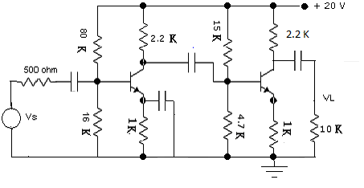 | 7  8
2. | - A power transistor working in class A operation is supplied from a 12 V battery. The maximum collector current change is 100 mA. Find the power transferred to 5 Ω loudspeaker, if it is transformer – coupled, for maximum power transference and also find the turn ratio of the transformer.  - Justify the statement “Negative feedback increases bandwidth and SNR”. | 7  8
3. | - What are the essential condition for oscillation. Explain Hartley oscillator with circuit Diagram. Derive the expression for the frequency of oscillator?  - With the help of necessary circuit diagrams and derivations, discuss the applications of an OP-Amp as a summer and Integrator. | 7  8
4. | - In a balanced network, arm AB consist of a resistance of 500Ω in series with an inductor of 0.18H, arm BC and arm DA are non-inductive resistances of 1000Ω each and CD arm is unknown. A potential difference of 5V at a frequency 5000/ 2π is applied between points A and C. Determine the constants of unknown arm.  - “A spring control permanent magnet moving coil instrument have a uniform scale” .Justify the statement. | 8  7
5. | - Define transducer. What characteristics do you consider while selecting a transducer? Explain them in brief.  - A resistance strain gauge with a gauge factor of 2 is fastened to a steel member subjected to a stress of 1250 Kg/cm².The modulus of elastic of a steel is approximately 2.1*10⁶ Kg/cm². Calculate the change in resistance of strain gauge element due to applied stress and also compute Poisson’s ratio. | 7  8
6. | - Design a binary weighted resistor DAC with digital input 101011. Also determine analog output voltage for given input. Assume V_{ref} = + 8 V.  - Give the functional details of a type of recorder which can be employed for plotting the current versus voltage curve of any transistor and diodes. | 8  7
7. | Write short notes on (Any Two)  - Cross over distortion  - Inverting and Non inverting Amplifier  - Successive type ADC | 5×2

